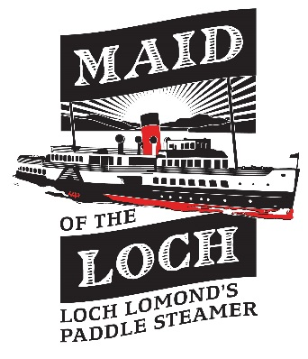
NEWS RELEASE

FULL STEAM AHEAD FOR LOCH LOMOND’S MAID OF THE LOCH
HLF are supporting the £5.5 million project to restore Maid of the Loch, Loch Lomond’s Paddle Steamer, to steam operation once more.

“Brilliant – ‘Maid’ it”, was the comment from Phil Preston, Chairman of the Loch Lomond Steamship Company, the charity that owns the Maid of the Loch. “This has been a 20 year cause, during which we have raised and reinvested over £1.9 million and committed over 80,000 hours to restoring the ship. With this promise of around £3.8 million from HLF, we now need to do the hard work of raising the other £1.7 million”, he said. Then he added with a huge smile, “I guess it’s now Full Steam Ahead!”

Colin McLean, Head of the Heritage Lottery Fund in Scotland, said:
“As with all ships, restoring the Maid of the Loch to full sailing condition is going to be an enormous challenge. By giving this initial support, we have given its owners the opportunity to see whether they can meet that challenge, and we wish them well in their endeavours.”

This is a Round 1 Pass, meaning that the charity can prepare all the necessary technical surveys, drawings, and specifications for the ship’s rebuild. Included in this will be a big effort to get people involved, and to record and publicise the various stages of the rebuild. The Round 1 Pass is a vital first stage of the overall project and is worth £230,400.

Local MSP, Jackie Baillie said: "This is tremendous news and the grant will help the Maid of the Loch sail once again on Loch Lomond. The board and volunteers have painstakingly restored the Maid and their vision has driven the project forward. We are all grateful to them for their efforts. We are blessed with stunning scenery at Loch Lomond, Scotland's first National Park, and what better way to see it than from the water, aboard the Maid of the Loch."

Stuart McMillan MSP attended the celebrations and said, “I am delighted that the Maid campaign has received this huge financial boost and look forward to seeing the Maid once again sailing on Loch Lomond. There is still much work to be done but this Heritage Lottery Fund investment should give confidence to other potential investors”.

John Beveridge, Director and Founder of the charity, was understandably over the moon. “All our volunteers, sponsors, and supporters have been wonderful over the years. Now having the support of the HLF, we will transform the Maid from a static venue to an historic icon for West Dunbarton and Scotland. We can provide training, jobs, and investment. Maid of the Loch will make the Bonnie Banks come alive and give visitors an experience of Loch Lomond – and Scotland - they will never forget”.

The engagement of consultants and marine experts will begin immediately with all necessary surveys, reports, and costs being ready for the spring of 2016. The ship will meet the latest marine safety standards, and be fitted with a lift to enable access for all. All being well, it is anticipated that Maid of the Loch will sail again in 2018.
________________________________________________________Ends 16 August 2015

NOTES TO EDITORS

The main photo shows the charity’s volunteers celebrating the good news on board the Maid flanked by MSP’s Stuart McMillan and Jackie Baillie on 15 August (Rosie Jake Photography).

The two photos of the Maid of the Loch show her firstly in the condition LLSC found her in, before any restoration work was begun, in 1992; the other photo shows the Maid as she now is, after 20 years’ voluntary effort (Loch Lomond Steamship Company)

- Maid of the Loch was built in 1953 and was withdrawn from service in 1981, having carried over 3 million passengers. She has been owned by several different companies but has remained tied up at Balloch ever since. By 1992 the Maid had been vandalised and damaged and was in danger of sinking
- The Loch Lomond Steamship Company, a charity registered in Scotland No. SC 024062, were given the ship – free of charge – and have owned her since 1996. There is no paid staff - everyone is a volunteer. www.maidoftheloch.org
- LLSC's aim was always to return the Maid to steam operation on Loch Lomond. The charity won HLF funding in 2006 to rebuild the Grade A listed Balloch Steam Slipway; has rebuilt Balloch Pier; created new car parking; and restored the Maid from a vandalised state to an established visitor attraction. The present public appeal stands at over £150,000.
- The Heritage Lottery Fund gives grants to sustain and transform the UK’s heritage. www.hlf.org.uk

Further information from John Beveridge 0755 282 2251
Director, Loch Lomond Steamship Company

